**Practical 7**

**input**

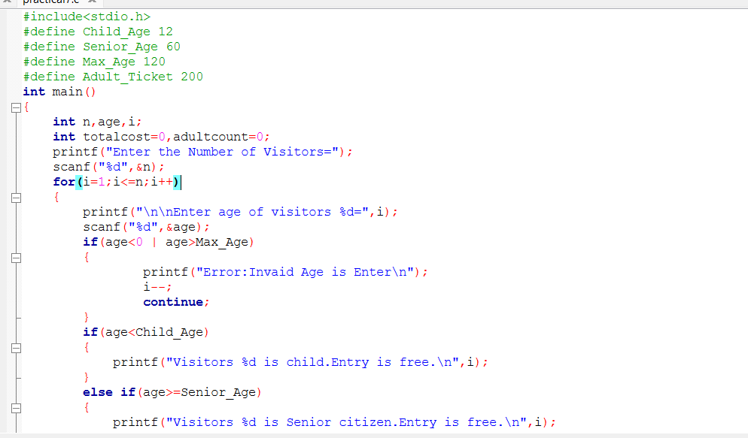

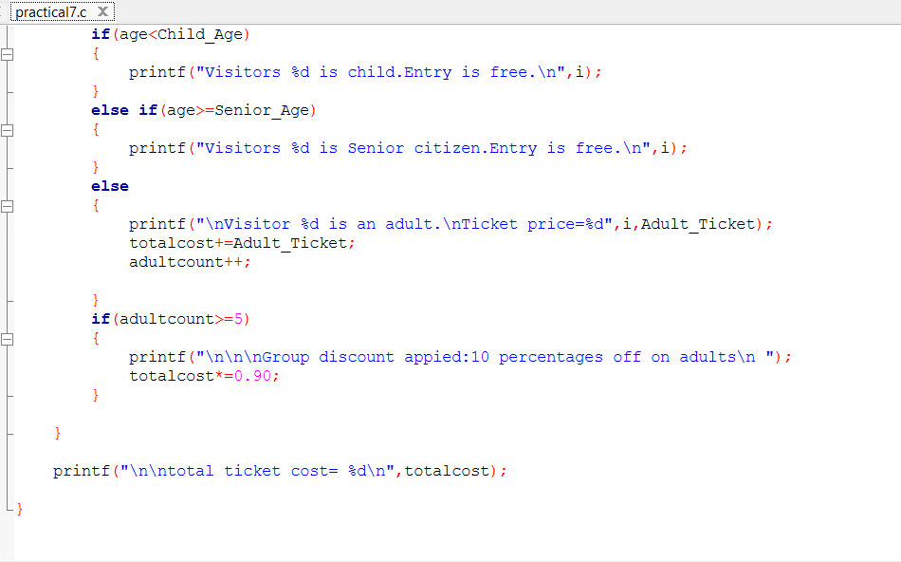

**Output :**

